**Input Data**:

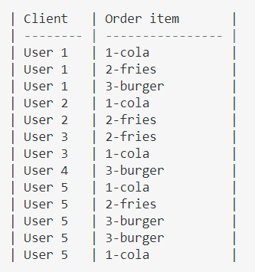

**Transformation Logic**: I have a table with 2 columns, 1st is client name let's say, and second is his choices. Note he can choose multiple choices (1 or more)! and he can also do a 2nd order as well!

1. Rule: In order for client 3 the items must be ordered sequentially when concatenated!
2. Rule: In order for client 5 we have 2 orders, detected simply by having a duplicate item for that order so it was put in a new row!

**Output**:

